Weather instrument: A barometer
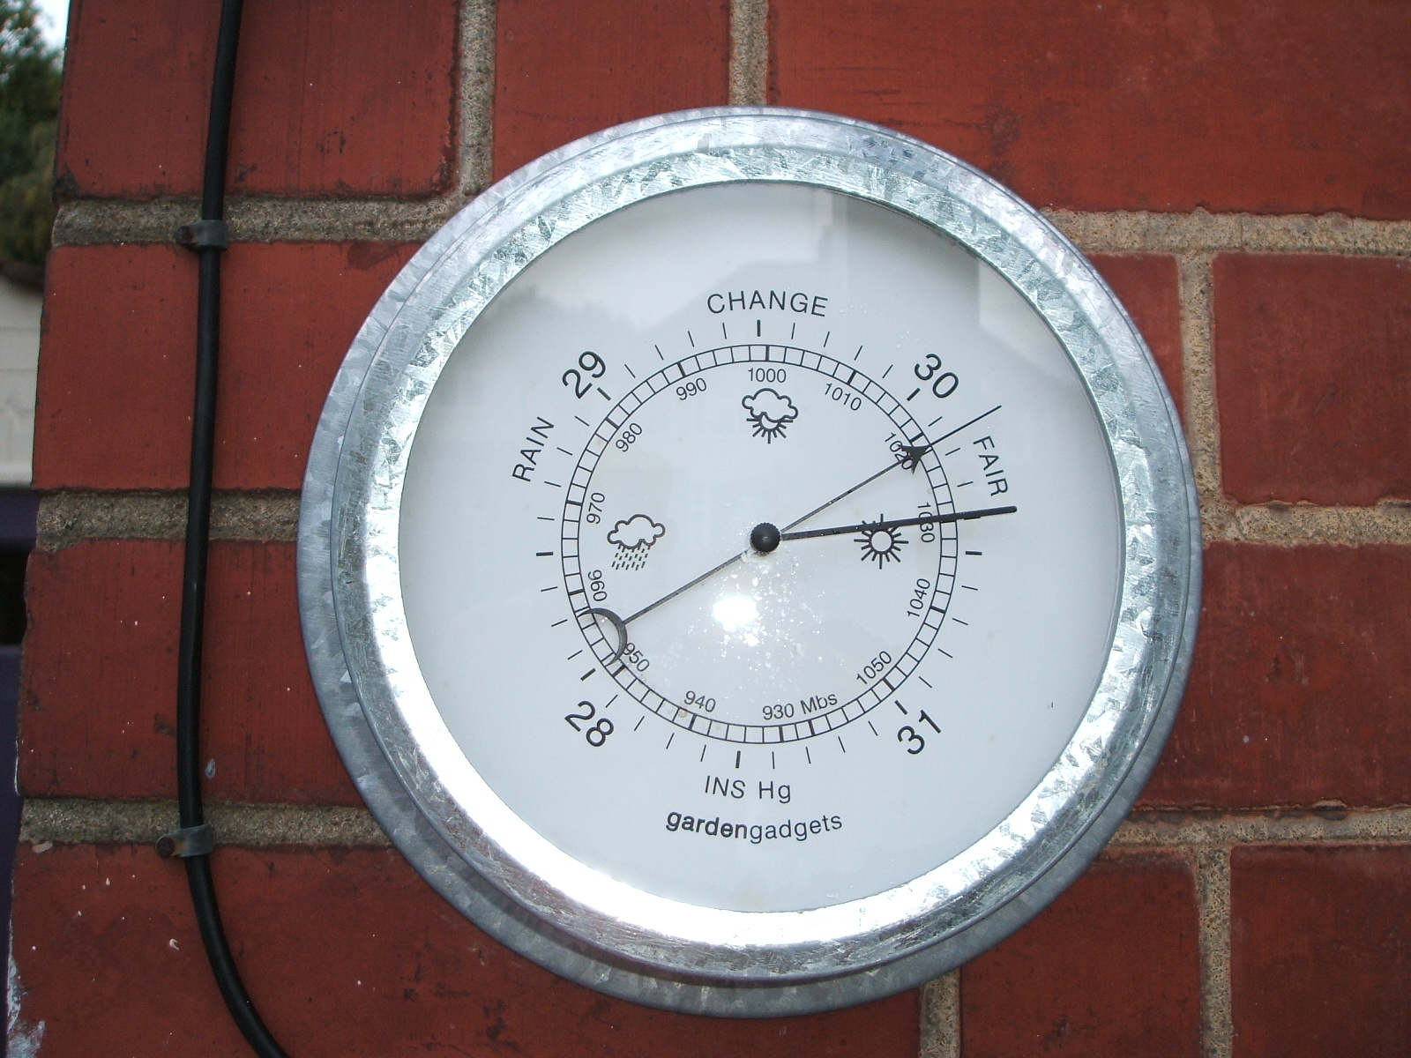
Angellous, Barometer, http://commons.wikimedia.org/wiki/File:Barometer.jpg

